Problem: PH company is a bicycles manufacturer, and it produces two types of products: street and road bicycles. The final products are put together via two assembling processes: 1 and 2. There are 3 time periods. Below is process costs for process 1 and process 2 and resource requirement per unit:

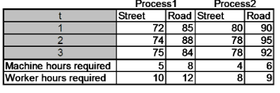

To meet customer demands in time in the US, planning department conducted a demand forecasting and counted current initial inventory.

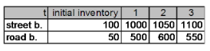

Besides, the information about available capacity(hours) and holding costs per bike are below:

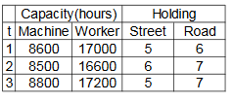

Help planning department to determine the aggregate production plan that minimizes the cost of meeting customer’s demands.